FOOD CONNECT: TO SUPPLY LEFT OVER FOOD TO POOR

***By***

# DEEPIKA KOLLI

[**(322103311025@gvpce.ac.in)**](mailto:(322103311025@gvpce.ac.in))

**1**

# Project Overview

This project, **"Food Connect: To Supply Leftover Food to Poor,"** is focused on creating a platform to streamline the redistribution of surplus food to underserved communities, designed to address the dual challenge of food wastage and hunger. The goal is to deliver a comprehensive solution by leveraging the Salesforce platform with tools like custom objects, Lightning apps, and automation workflows. Through this project, we aim to enhance operational efficiency, transparency, and community engagement while supporting the long-term vision of creating a sustainable food-sharing ecosystem.

# Objectives

## Business Goals:

* To reduce food wastage by connecting surplus food providers with underserved communities in need.
* To create a sustainable platform that promotes transparency and accountability in food redistribution.
* To foster community engagement by encouraging volunteers and donors to participate actively.

## Specific Outcomes:

* **Real-Time Tracking:** Implement a dashboard to monitor donations, volunteer tasks, and delivery progress.
* **Automation of Processes:** Streamline donor requests, volunteer coordination, and food pickups using Salesforce Flows and Triggers.

## 2

* **User-Friendly Interface:** Develop intuitive forms and tabs for easy onboarding of donors, volunteers, and drop-off points.
* **Comprehensive Reporting:** Generate detailed reports to evaluate the impact, measure key performance indicators (KPIs), and support data- driven decision-making.
* **Scalability:** Create a replicable model that can be extended to other regions or scaled for larger operations.

# Salesforce Key Features and Concepts Utilized

### Custom Objects and Fields:

* + Created tailored objects to manage donor information, volunteer tasks, food pickup requests, and drop-off locations.

### Lightning App Builder:

* + Designed an intuitive and visually appealing Lightning app interface for users to easily navigate and manage tasks.

### Flows and Automation:

* + Implemented automation for task assignments, notifications, and tracking of food donations and pickups to reduce manual efforts.

### Triggers:

* + Developed Apex triggers to ensure data consistency and automate backend processes, such as updating task statuses or alerting users.

### Reports and Dashboards:

* + Built dynamic dashboards and reports to provide real-time insights into donation volumes, volunteer activities, and delivery progress.

**3**

# Detailed Steps to Solution Design

|  |  |
| --- | --- |
| **Topic no.** | **Topic Name** |
| **1.** | **Creating Objects:**   * 1. Create Venue Object   2. Create Drop-Off Point Object   3. Create Task Object   4. Create Volunteer Object   5. Create Execution Details Object |
| **2.** | **Creating Tabs:**   * 1. Create Venue Tab   2. Create Drop-Off Point Tab   3. Create Task Tab   4. Create Volunteer Tab   5. Create Execution Details Tab |
| **3.** | **Create A Lightning App** |
| **4.** | **Fields:**   * 1. Creation of Relationship Fields In Objects   2. Creation of Fields For The Venue Object   3. Creation of Fields For The Drop-Off Point Object   4. Creation of Fields For The Task Object   5. Creation of Fields For The Volunteer Object   6. Creation of Fields For The Execution Details Object |
| **5.** | Create Flow to create a record in Venue object |

## 4

|  |  |
| --- | --- |
| **6.** | **Trigger:**   * 1. Create A Trigger   2. Trigger Code |
| **7.** | **Creation Of Users:**   * 1. Creation Of User1   2. Creation Of User2,user3 |
| **8.** | **Public Groups:**   * 1. Creation Of Public Group 1   2. Creation Of Public Group 2 |
| **9.** | **Creation Of Report Types** |
| **10.** | **Reports:**   * 1. Creation Of Report On venue With Drop-Off Point With Volunteer   2. Creation Of Report On Volunteer With Execution Details And Tasks |
| **11.** | **Dash Boards:**   * 1. Adding Venue And Drop-Off Point To Report The Dashboard   2. Adding Volunteer Task Report To The Dashboard   3. Adding A Picture To The DashBoard |
| **12.** | **Creation Of Sharing Rules** |
| **13.** | **Creation Of Home Page** |

**5**

### Creating Objects

Objects in Salesforce are database tables that allow you to store data specific to your organization. Each object comprises records (rows) and fields (columns) that help organize and structure your data efficiently. We use objects to manage and relate various types of information, enabling seamless data tracking, reporting, and analysis within the Salesforce platform.

Objects allow users to manage various types of information such as customer accounts, contacts, opportunities, and custom data specific to the organization. Salesforce provides standard objects like Account, Contact, and Opportunity, and users can also create **custom objects** to suit unique business needs.

### To create an object:

1. 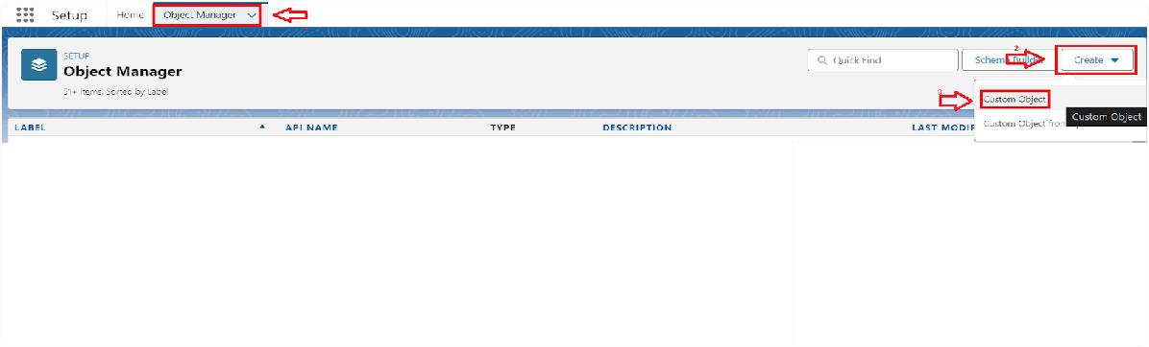From the setup page > Click on Object Manager > Click on Create > Click on Custom Object.
2. On Custom object defining page:
3. Enter the label name, plural label name, click on Allow reports, Allow search.

## 6

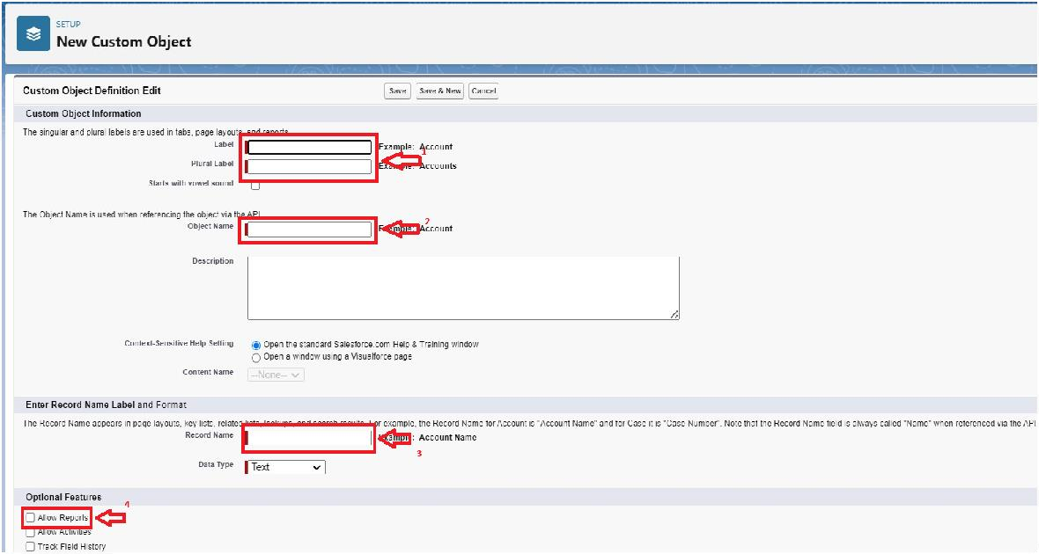

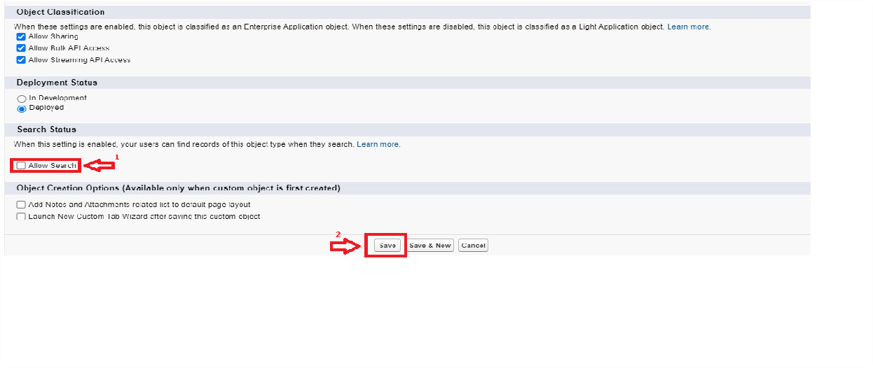

1. Click on Save.

### Create Venue Object:

To create an object:

* + 1. From the setup page >> Click on Object Manager >> Click on Create

>>Click on Custom Object.

* + - 1. Enter the label name >> Venue
      2. Plural label name >> Venues

## 7

* + - 1. Enter Record Name Label and Format Record Name >> Venue Name Data Type >> Text
    1. Click on Allow reports and Track Field History,Allow Activities.
    2. Allow search >> Save.

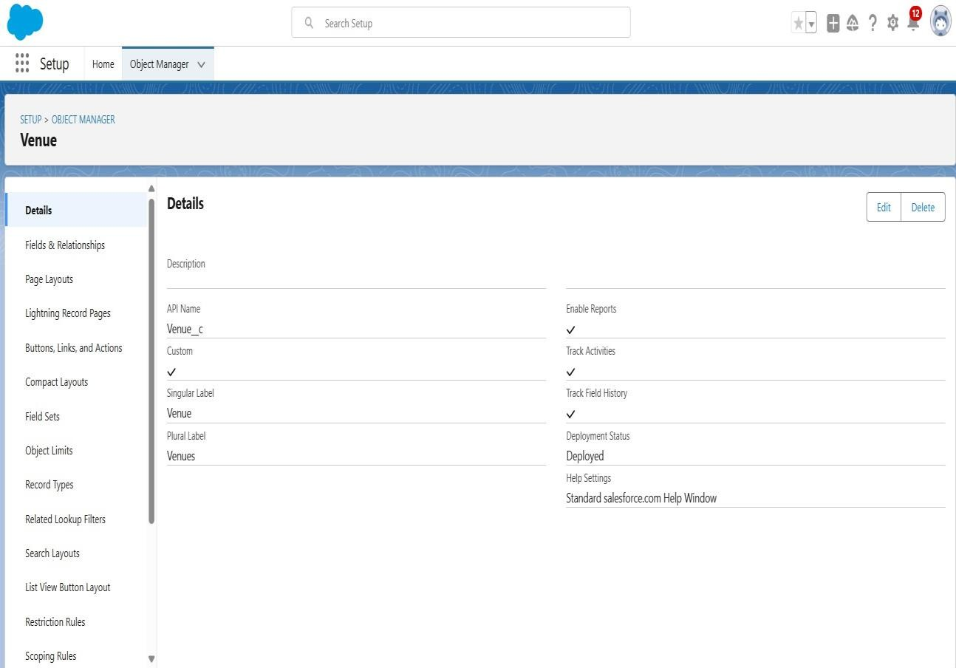

### Create Drop-Off Point Object:

To create an object:

* + 1. From the setup page >> Click on Object Manager >> Click on Create

>> Click on Custom Object.

* + - 1. Enter the label name >> Drop-Off Point
      2. Plural label name>> Drop-Off Points
      3. Enter Record Name Label and Format Record Name >> Drop-Off point Name Data Type >> Text
    1. Click on Allow reports and Track Field History,Allow Activities
    2. Allow search >> Save.

## 8

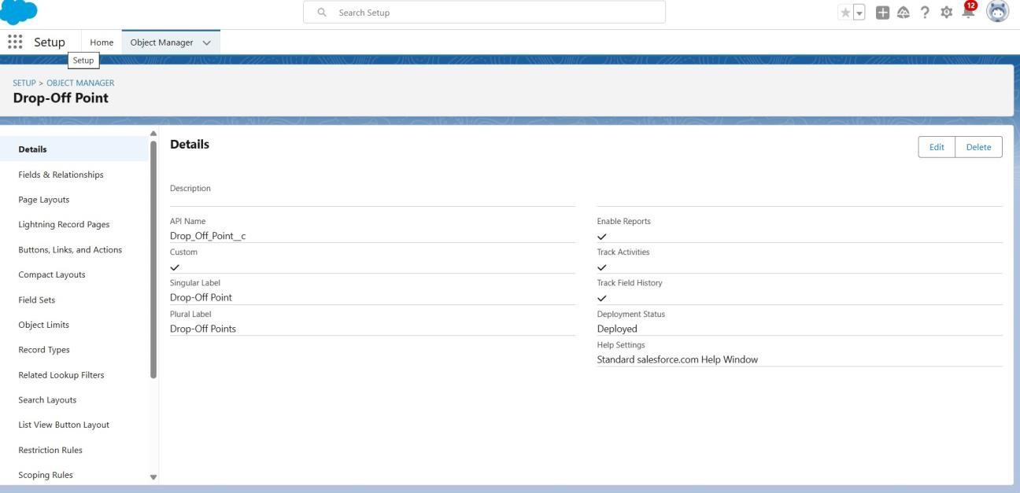

### Create Task Object:

To create an object:

* + 1. From the setup page >> Click on Object Manager >> Click on Create

>> Click on Custom Object.

* + - 1. Enter the label name>> Task
      2. Plural label name>> Tasks
      3. Enter Record Name Label and Format Record Name >> Task Name

Data Type >> Text

* + 1. Click on Allow reports and Track Field History,Allow Activities
    2. Allow search >> Save.

## 9

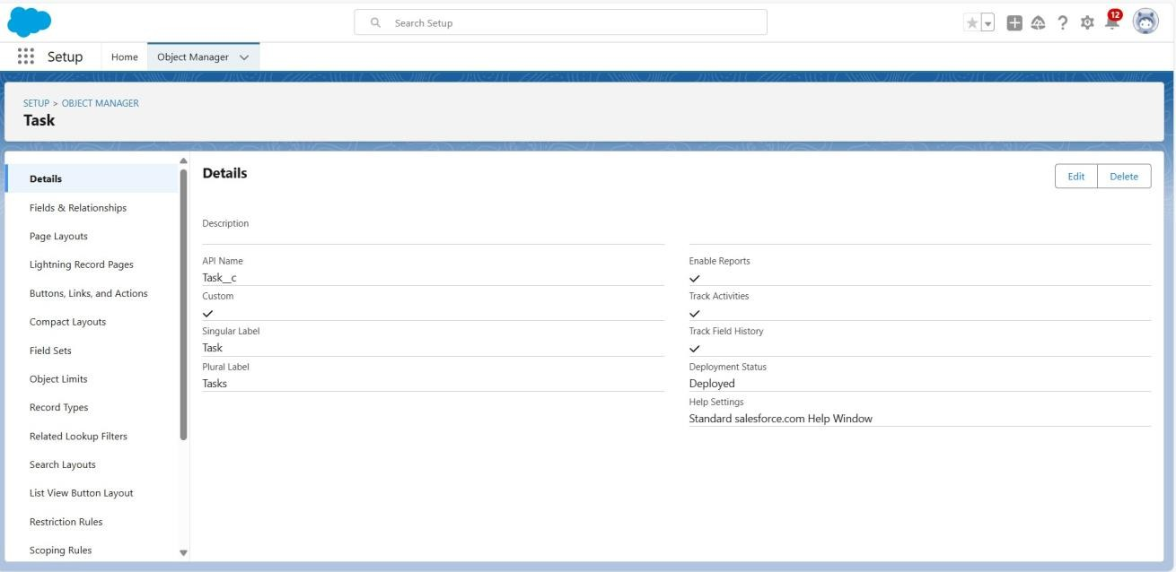

### Create Volunteer Object:

To create an object:

* + 1. From the setup page >> Click on Object Manager>> Click on Create

>> Click on Custom Object.

* + - 1. Enter the label name>> Volunteer
      2. Plural label name>> Volunteers
      3. Enter Record Name Label and Format Record Name >> Volunteer Name Data Type >> Text
    1. Click on Allow reports and Track Field History, Allow Activities
    2. Allow search >> Save.

## 10

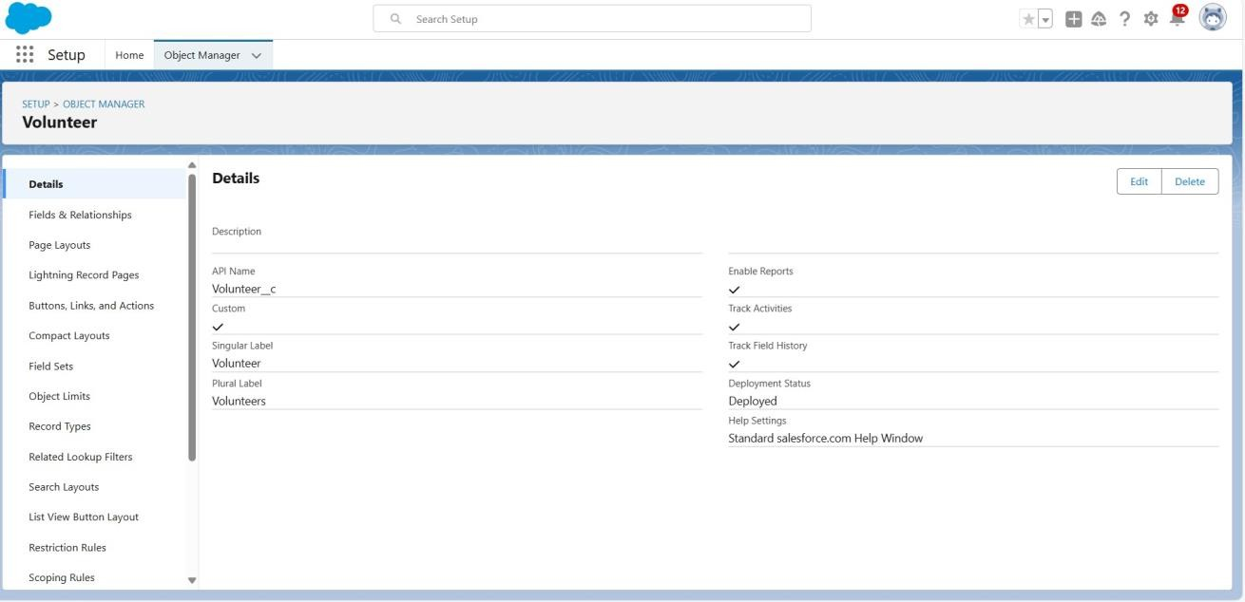

### CreateExecution Detail Object:

To create an object:

* + 1. From the setup page >> Click on Object Manager >> Click on Create

>> Click on Custom Object.

* + - 1. Enter the label name >> Execution Detail
      2. Plural label name >> Execution Details
      3. Enter Record Name Label and Format Record Name >> Execution Detail Name Data Type >> Text
    1. Click on Allow reports and Track Field History, Allow Activities
    2. Allow search >> Save.

## 11

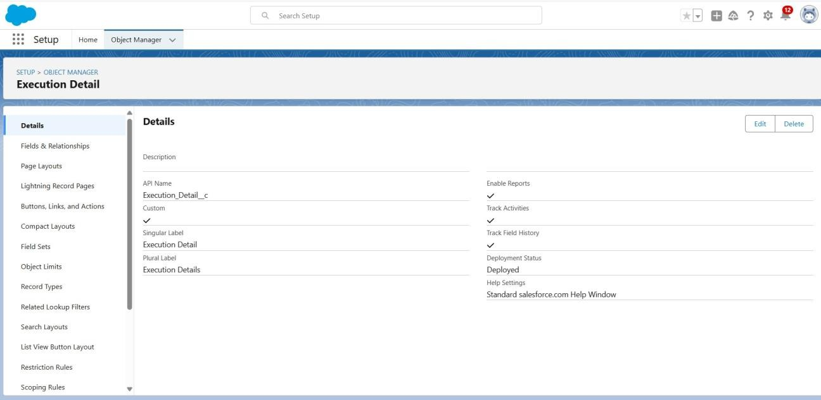

### Creating Tabs

A **tab** is a user interface component that helps users organize, access, and manage records of different **objects** within the platform. Salesforce objects represent different types of data, such as Accounts, Contacts, Opportunities, or Custom Objects, and each object has its own tab. Here's a more detailed explanation of what a tab is and how it functions

### Creating Venue Tab:

To create a Tab:(Venue)

* + 1. Go to setup page >> type Tabs in Quick Find bar >> click on tabs >> New (under custom object tab)

## 12

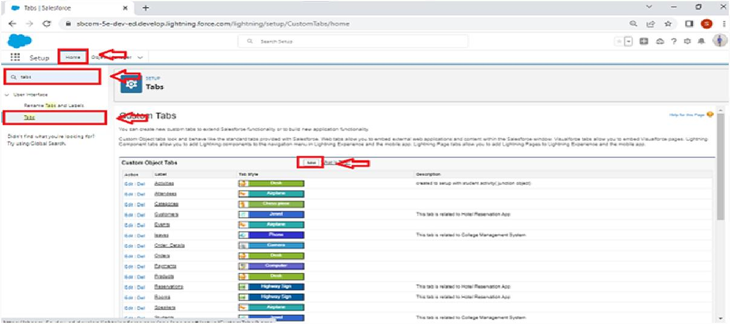

1. Select Object(Venue) >> Select the tab style >> Next (Add to profiles page) keep it as default >> Next (Add to Custom App) uncheck the include tab .
2. Make sure that the Append tab to users' existing personal customizations is checked.
3. Click save

### Creating Remaining tabs:

* + 1. Now create the Tabs for the remaining Objects, they are “Drop-Off Point, Task, Volunteer, Execution Details”.
    2. Follow same steps of **2.1**

## 13

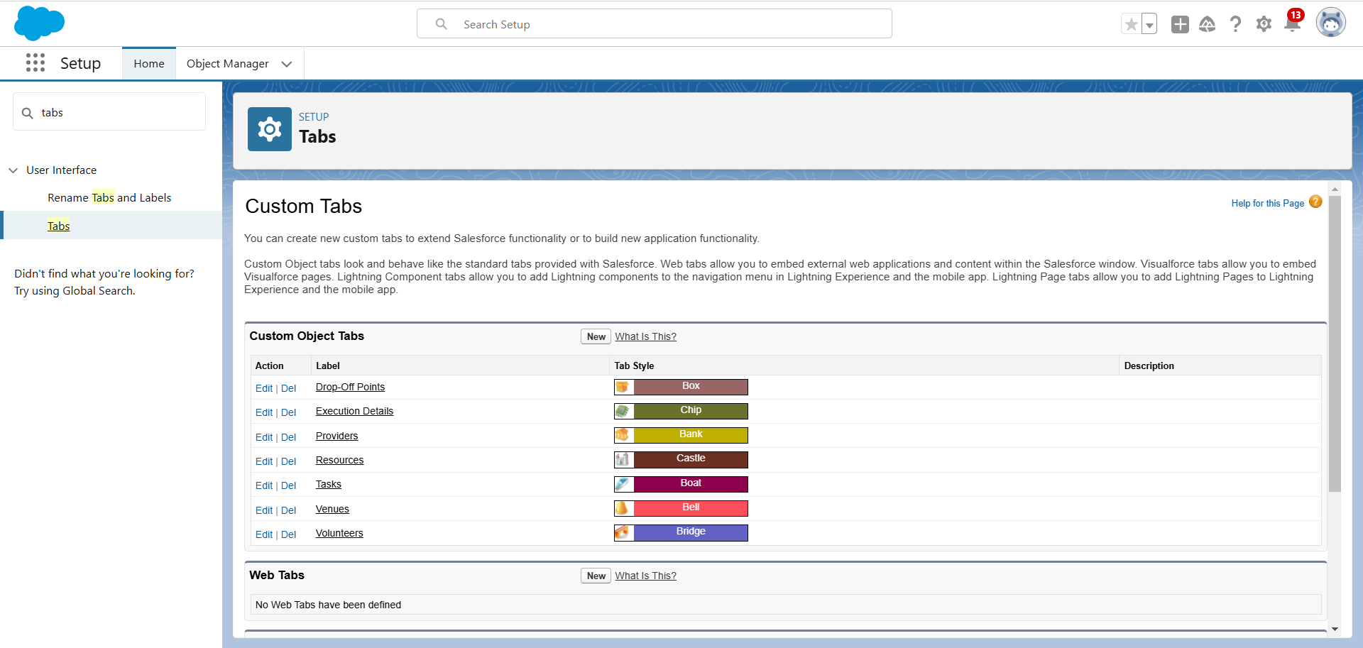

### Create A Lightning app

**To create a lightning app page:**

1. Go to setup page >> search “app manager” in quick find >> select “app manager” >> click on New lightning App.

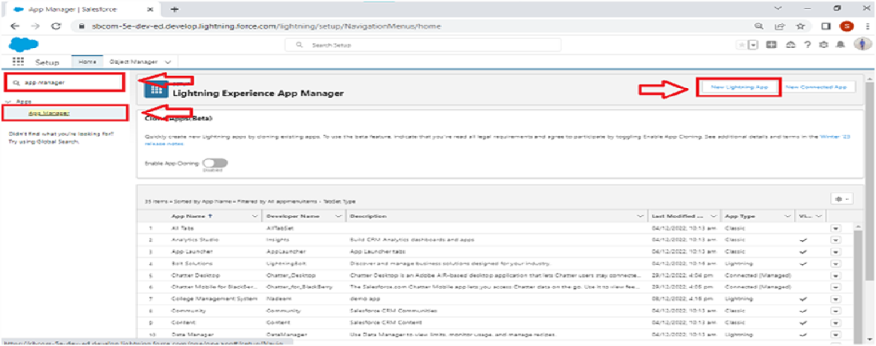

1. Fill the app name in app details and branding as follow

## 14

App Name : FoodConnect

Developer Name : This will auto populated

Image : optional (if you want to give any image otherwise not mandatory)

Primary color hex value : keep this default.

1. Then click Next >> (App option page)Set Navigation Style as Standard Navigation >> Next.

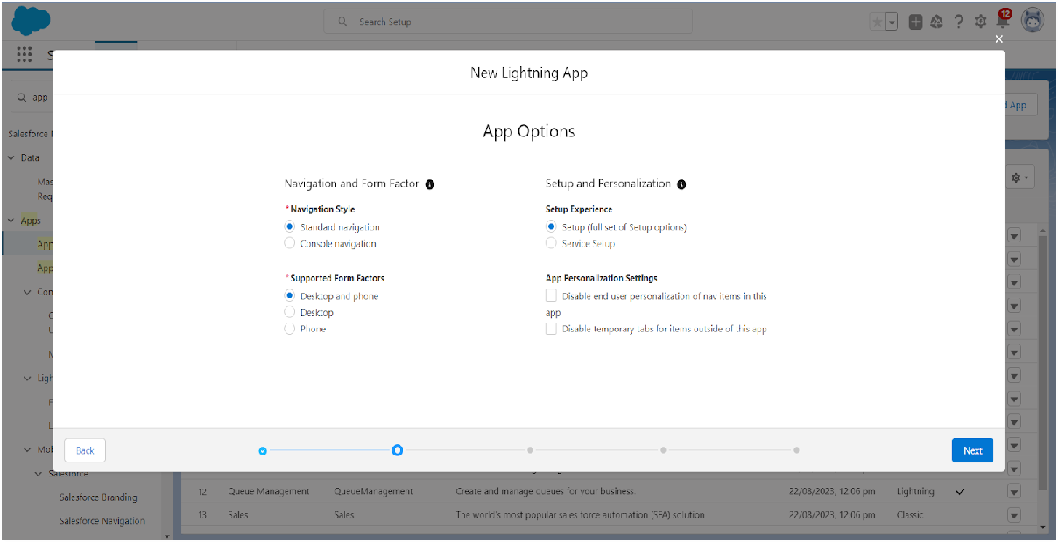

1. (Utility Items) keep it as default >> Next.
2. To Add Navigation Items:

## 15

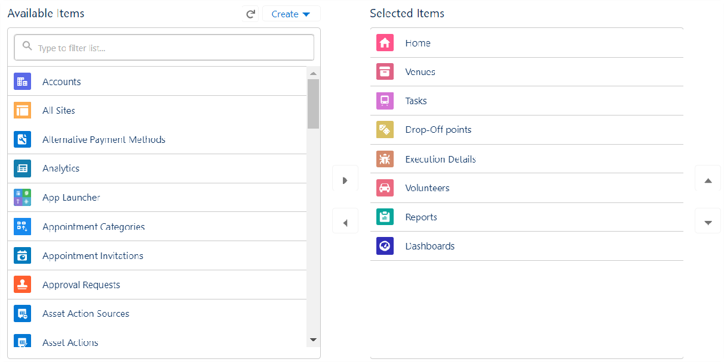

Search for the item in the (Home, Venue, Drop-Off Point, Task, Volunteer, Execution Details, Reports) from the search bar and move it using the arrow button >> Next >> Next.

1. To Add User Profiles:

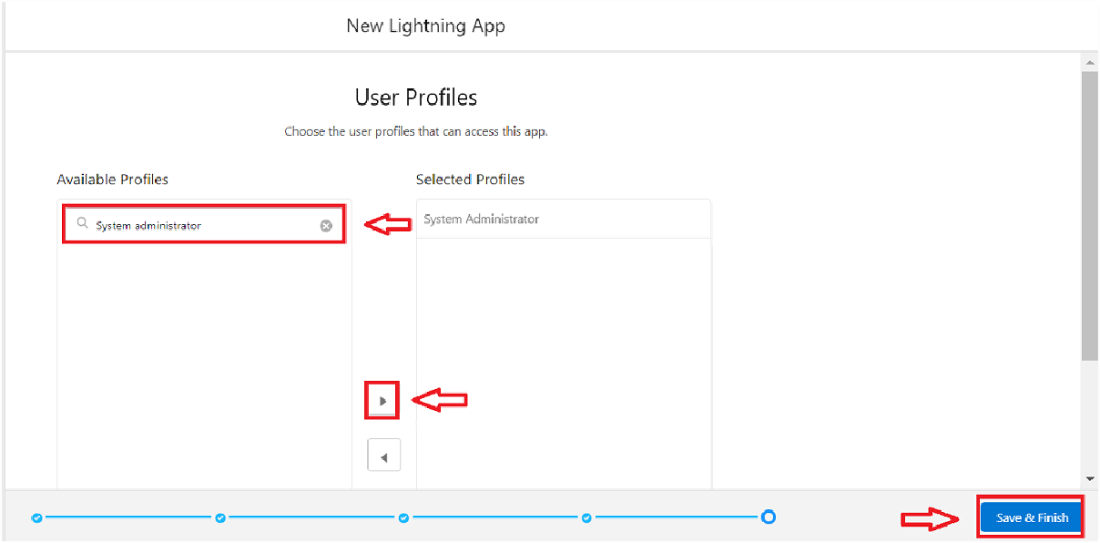

## 16

Search profiles (System administrator) in the search bar >> click on the arrow button >> save & finish.

### Fields

Fields are fundamental building blocks of objects. They store individual pieces of data in a record and define the data type, behavior, and purpose of that data. Fields are associated with both **standard** and **custom objects**. Fields in Salesforce are data containers within objects that store specific pieces of information, such as text, numbers, or dates.

### Creation of Relationship Fields In Objects:

Creation of Lookup Relationship Field on Volunteer Object :

* + 1. Go to setup >> click on Object Manager >> type object name(Volunteer) in the search bar >> click on the object.

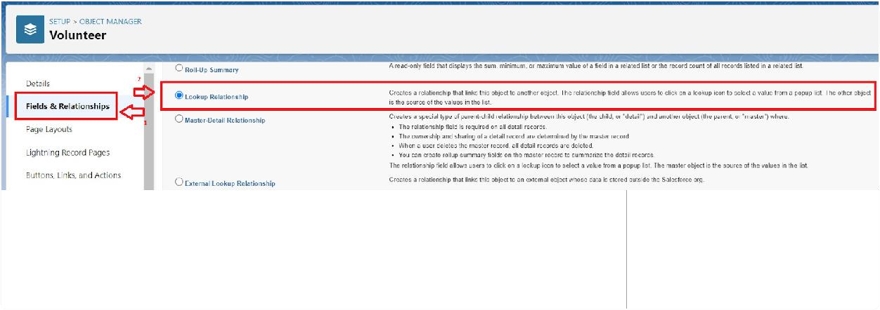

* + 1. Now click on “Fields & Relationships” >> New
    2. Select Master Detail relationship
    3. Select the related object “Drop-Off point” and click next.

## 17

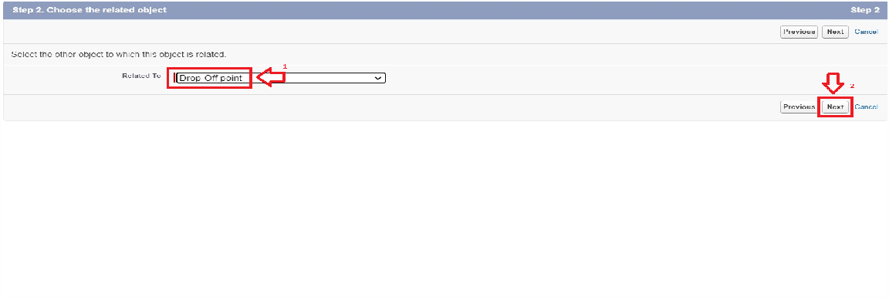

* + 1. Field Name : Drop_Off_point
    2. Field label : Auto generated
    3. Next >> Next >> Save.

Creation of Master Detail Relationship Field on Execution Details Object :

* + 1. Go to setup >> click on Object Manager >> type object name(Execution Details) in the search bar >> click on the object.
    2. Now click on “Fields & Relationships” >> New
    3. Select Master Detail relationship
    4. Select the related object “Volunteer” and click next.
    5. Field Name : Volunteer
    6. Field label : Auto generated
    7. Next >> Next >> Save.

Creation of Master Detail Relationship Field on Execution Details Object :

* + 1. Go to setup >> click on Object Manager >> type object name(Execution Details) in the search bar >> click on the object.
    2. Now click on “Fields & Relationships” >> New
    3. Select Master Detail relationship
    4. Select the related object “Task” and click next.

## 18

* + 1. Field Name : Task
    2. Field label : Auto generated
    3. Next >> Next >> Save.

Creation of Lookup Relationship Field on Drop-Off Point Object :

* + 1. Go to setup >> click on Object Manager >> type object name(Drop- Off Point) in the search bar >> click on the object.
    2. Now click on “Fields & Relationships” >> New
    3. Select Lookup relationship
    4. Select the related object “Venue” and click next.
    5. Field Name : Venue
    6. Field label : Venue c
    7. Next >> Next >> Save.

Creation of Lookup Relationship Field on Task Object :

* + 1. Go to setup>> click on Object Manager >> type object name(Task) in the search bar >> click on the object.
    2. Now click on “Fields & Relationships” >> New
    3. Select Lookup relationship
    4. Select the related object “Venue” and click next.
    5. Field Name : Sponsored By
    6. Field label : Auto generated
    7. Next >> Next >> Save.

Creation of Lookup Relationship Field on Task Object :

## 19

* + 1. Go to setup>> click on Object Manager >> type object name(Task) in the search bar >> click on the object.
    2. Now click on “Fields & Relationships” >> New
    3. Select Lookup relationship
    4. Select the related object “Drop-Off point” and click next.
    5. Field Name : Drop-Off point
    6. Field label : Auto generated
    7. Next >> Next >> Save.

### Creation Of Fields For The Venue object:

* + 1. Go to setup>> click on Object Manager >> type object name(Venue) in search bar >> click on the object.
    2. Now click on “Fields & Relationships” >> New
    3. Select Data type as a “Email” and Click on Next
    4. Fill the Above as following:
       - Field Label : Contact Email
       - Field Name : Contact Email
       - Click on required check box
       - Click on Next >> Next >> Save and new.

### To create another fields in an object:

* + 1. Go to setup >> click on Object Manager >> type object name(Venue) in search bar >> click on the object.
    2. Now click on “Fields & Relationships” >> New
    3. Select Data type as a “Phone” and Click on Next
    4. Fill the Above as following:
       - Field Label : Contact Phone

## 20

* + - * Field Name : Contact Phone
      * Click on required check box
      * Click on Next >> Next >> Save and new.

### To create another fields in an object:

1. Go to setup >> click on Object Manager >> type object name(Venue) in search bar >>click on the object.
2. Now click on “Fields & Relationships” >> New
3. Select Data type as a “Geolocation” and Click on Next
4. Fill the Above as following:
   * Field Label : Location
   * Decimal Places : 4
   * Field Name : Location
   * Description : Enter the Geolocation of your Venue
   * Click on Next >> Next >> Save and new.

To create another fields in an object:

* + 1. Go to setup >> click on Object Manager >> type object name(Venue) in search bar >> click on the object.
    2. Now click on “Fields & Relationships” >> New
    3. Select Data type as a “Long Text Area” and Click on Next
    4. Fill the Above as following:
       - Field Label : Venue Location
       - Field Name : Venue_Location
       - Click on Next >> Next >> Save and new.

## 21

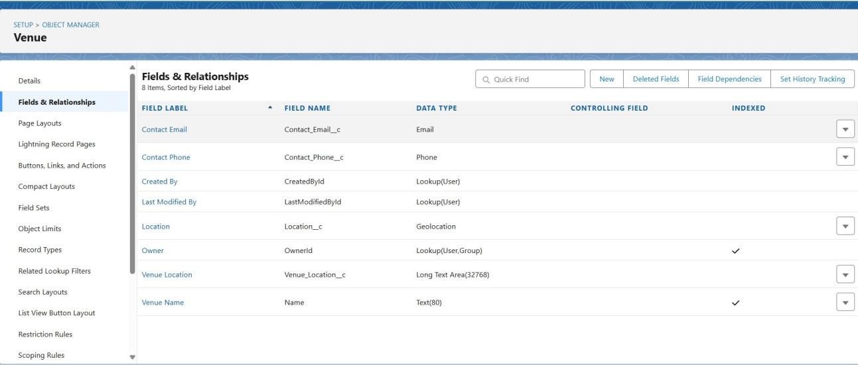

### Creation Of Fields For The Drop-Off Point object:

Go to setup >> click on Object Manager >> type object name(Drop-Off point) in search bar >> click on the object.

* 1. Now click on “Fields & Relationships” >> New
  2. Select Data type as a “Geolocation” and Click on Next
  3. Fill the Above as following:
     + Field Label : Location 2
     + Field Name : gets auto generated
     + Description : Enter the Geolocation of the Drop off Point
     + Geolocation Options : select Decimal
     + Decimal Places : 4
     + Click on Next >> Next >> Save and new.

To create another fields in an object:

1. Go to setup >> click on Object Manager >> type object name(Drop-Off point) in search bar >> click on the object.
2. Now click on “Fields & Relationships” >> New

## 22

1. Select Data type as a “Formula” and Click on Next
2. Fill the Above as following:
   * Field Label : distance calculation
   * Field Name : distance_calculation
   * Formula Return Type : Number
   * Formula Options : DISTANCE( Location_2 c , Venue r.Location c , 'km')
   * Click on Next >> Next >> Save and new.

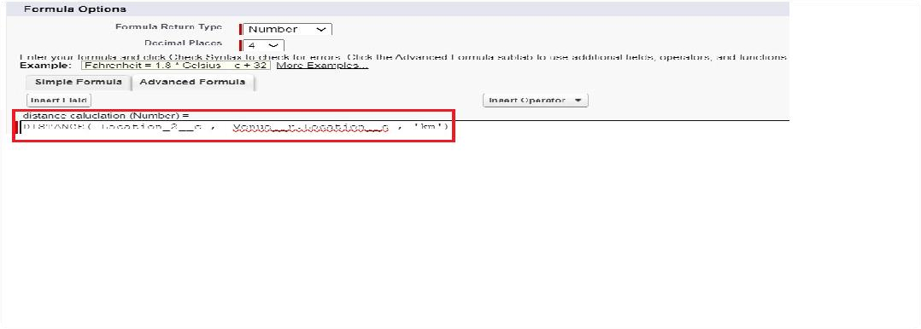

To create another fields in an object:

1. Go to setup >> click on Object Manager >> type object name(Drop-Off point) in search bar >> click on the object.
2. Now click on “Fields & Relationships” >> New
3. Select Data type as a “Picklist” and Click on Next
4. Fill the Above as following:
   * Field Label : State
   * Field Name : State
   * Enter values, with each value separated by a new line : Andhra Pradesh

Arunachal Pradesh Assam

Bihar

## 23

Chhattisgarh Goa Gujarat

Haryana

Himachal Pradesh Jharkhand Karnataka

Kerala Maharashtra Madhya Pradesh Manipur Meghalaya Mizoram Nagaland Odisha Punjab Rajasthan Sikkim

Tamil Nadu Tripura Telangana Uttar Pradesh

Uttarakhand West Bengal

Andaman & Nicobar (UT) Chandigarh (UT)

Dadra & Nagar Haveli and Daman & Diu (UT) Delhi [National Capital Territory (NCT)] Jammu & Kashmir (UT)

## 24

Ladakh (UT) Lakshadweep (UT) Puducherry (UT)

* + Click on required check box
  + Click on Next >> Next >> Save and new.

To create another fields in an object:

1. Go to setup >> click on Object Manager >> type object name(Task) in search bar >> click on the object.
2. Now click on “Fields & Relationships” >> New
3. Select Data type as a “Number” and Click on Next
4. Fill the Above as following:
   * Field Label : Distance
   * Field Name : Distance
   * Length : 14
   * Decimal Places : 4
   * Click on required check box
   * Click on Next >> Next >> Save and new.

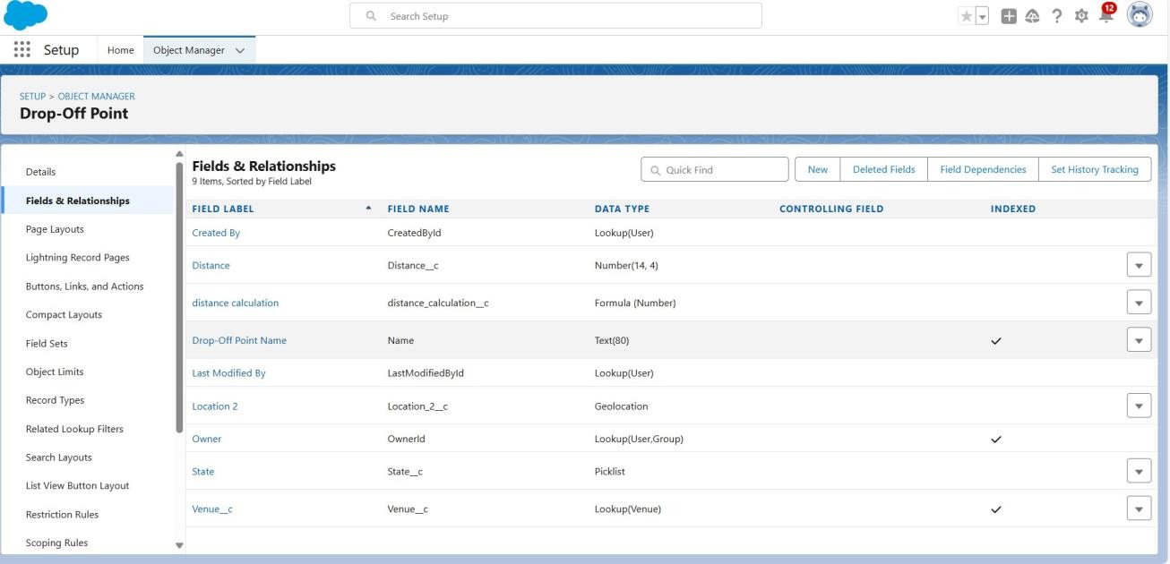

## 25

### Creation Of Fields For Task object:

Go to setup>> click on Object Manager >> type object name(Task) in search bar >> click on the object.

1. Now click on “Fields & Relationships” >> New
2. Select Data type as a “Auto Number” and Click on Next
3. Fill the Above as following:
   * Field Label : Task ID
   * Display Format : TASK-{0}
   * Starting Number : 1
   * Field Name : gets auto generated
   * Click on required check box
   * Click on Next >> Next >> Save and new.

To create another fields in an object:

1. Go to setup >> click on Object Manager >> type object name(Task) in search bar >> click on the object.
2. Now click on “Fields & Relationships” >> New
3. Select Data type as a “Date” and Click on Next
4. Fill the Above as following:
   * Field Label : Date
   * Field Name : Date
   * Click on required check box
   * Click on Next >> Next >> Save and new.

To create another fields in an object:

1. Go to setup >> click on Object Manager >> type object name(Task) in search bar >> click on the object.
2. Now click on “Fields & Relationships” >> New

## 26

1. Select Data type as a “Picklist (Multi-Select)” and Click on Next
2. Fill the Above as following:
   * Field Label : Food Category
   * Field Name : Food Category
   * Enter values, with each value separated by a new line : Veg Non-Veg

Salad Snack

* + Click on required check box
  + Click on Next >> Next >> Save and new.

To create another fields in an object:

1. Go to setup >> click on Object Manager >> type object name(Task) in search bar >> click on the object.
2. Now click on “Fields & Relationships” >> New
3. Select Data type as a “Number” and Click on Next
4. Fill the Above as following:
   * Field Label : Number of People Served
   * Field Name : Number_of_People_Served
   * Click on required check box
   * Click on Next >> Next >> Save and new.

To create another fields in an object:

1. Go to setup >> click on Object Manager >> type object name(Task) in search bar >> click on the object.
2. Now click on “Fields & Relationships” >> New
3. Select Data type as a “Text” and Click on Next
4. Fill the Above as following:

## 27

* + Field Label : Name of the Person
  + Field Name : Name_of_the_Person
  + Click on Next >> Next >> Save and new.

To create another fields in an object:

1. Go to setup>> click on Object Manager >> type object name(Task) in search bar >> click on the object.
2. Now click on “Fields & Relationships” >> New
3. Select Data type as a “Phone” and Click on Next
4. Fill the Above as following:
   * Field Label : Phone
   * Field Name : Phone
   * Click on Next >> Next>> Save and new.

To create another fields in an object:

1. Go to setup >> click on Object Manager >> type object name(Task) in search bar >> click on the object.
2. Now click on “Fields & Relationships” >> New
3. Select Data type as a “Pick List” and Click on Next
4. Fill the Above as following:
   * Field Label : Rating
   * Field Name : Rating
   * Enter values, with each value separated by a new line : 1 2

3

4

5

* + Click on Next >> Next >> Save and new.

## 28

To create another fields in an object:

1. Go to setup >> click on Object Manager >> type object name(Task) in search bar >> click on the object.
2. Now click on “Fields & Relationships” >> New
3. Select Data type as a “Long Text Area” and Click on Next
4. Fill the Above as following:
   * Field Label : Feedback
   * Field Name : Feedback
   * Click on Next >> Next >> Save and new.

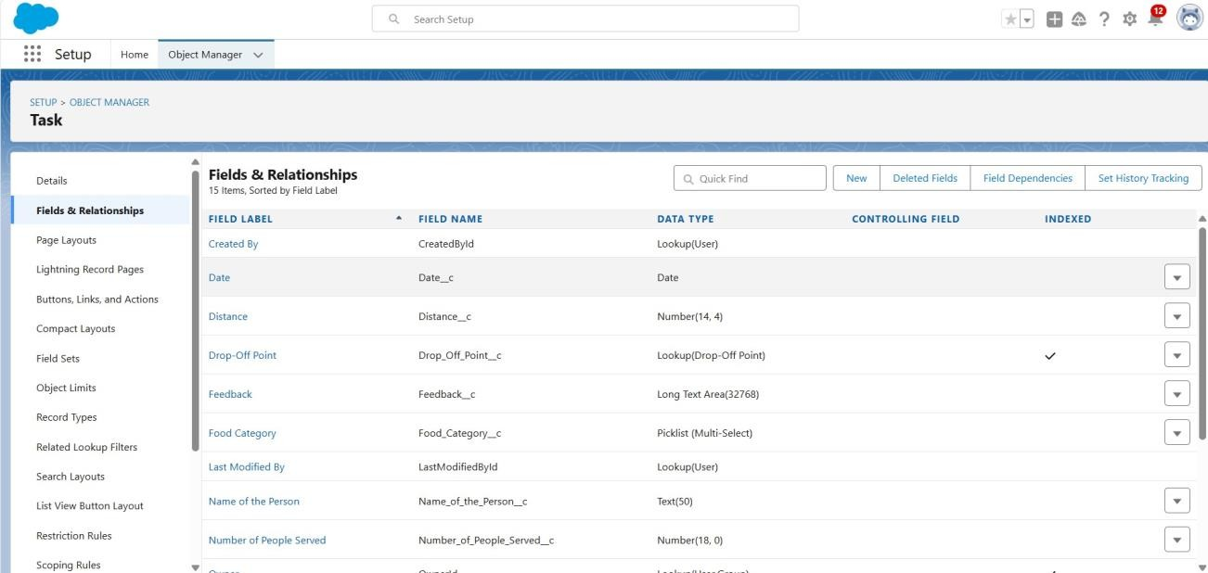

### Creation Of Fields For Volunteer object:

1. Go to setup >> click on Object Manager >> type object name(Volunteer) in search bar >> click on the object.
2. Now click on “Fields & Relationships” >> New
3. Select Data type as a “Auto Number” and Click on Next
4. Fill the Above as following:

## 29

* + Field Label : Volunteer ID
  + Field Name : gets auto generated
  + Click on required check box
  + Click on Next >> Next >> Save and new.
  + Click on Next >> Next >> Save and new.

To create another fields in an object:

1. Go to setup >> click on Object Manager >> type object name(Volunteer) in search bar >> click on the object.
2. Now click on “Fields & Relationships” >> New
3. Select Data type as a “Picklist” and Click on Next
4. Fill the Above as following:
   * Field Label : Gender
   * Field Name : Gender
   * Enter values, with each value separated by a new line : Female

Male

* + Click on Next >> Next >> Save and new.

To create another fields in an object:

1. Go to setup >> click on Object Manager >> type object name(Volunteer) in search bar >> click on the object.
2. Now click on “Fields & Relationships” >> New
3. Select Data type as a “Date” and Click on Next
4. Fill the Above as following:
   * Field Label : Available On
   * Field Name : Available On
   * Click on required check box

## 30

* + Click on Next >> Next >> Save and new.

To create another fields in an object:

1. Go to setup >> click on Object Manager >> type object name(Volunteer) in search bar >> click on the object.
2. Now click on “Fields & Relationships” >> New
3. Select Data type as a “Number” and Click on Next
4. Fill the Above as following:
   * Field Label : Age
   * Field Name : Age
   * Click on required check box
   * Click on Next >> Next>> Save and new.

To create another fields in an object:

1. Go to setup >> click on Object Manager >> type object name(Volunteer) in search bar >> click on the object.
2. Now click on “Fields & Relationships” >> New
3. Select Data type as a “Email” and Click on Next
4. Fill the Above as following:
   * Field Label : Email
   * Field Name : Email
   * Click on required check box
   * Click on Next>> Next >> Save and new.

To create another fields in an object:

1. Go to setup >> click on Object Manager >> type object name(Volunteer) in search bar >> click on the object.
2. Now click on “Fields & Relationships” >> New
3. Select Data type as a “Number” and Click on Next

## 31

1. Fill the Above as following:
   * Field Label : Contact Number
   * Field Name : Contact_Number
   * Click on required check box
   * Click on Next >> Next >> Save and new.

To create another fields in an object:

1. Go to setup >> click on Object Manager >> type object name(Volunteer) in search bar >> click on the object.
2. Now click on “Fields & Relationships” >> New
3. Select Data type as a “Text Area (Long)” and Click on Next
4. Fill the Above as following:
   * Field Label : Address
   * Field Name : Address
   * Click on Next >> Next >> Save and new.

To create another fields in an object:

1. Go to setup >> click on Object Manager >> type object name(Volunteer) in search bar >> click on the object.
2. Now click on “Fields & Relationships” >> New
3. Select Data type as a “Date” and Click on Next
4. Fill the Above as following:
   * Field Label : Date of Birth
   * Field Name : Date_of_Birth
   * Click on Next >> Next >> Save and new.

## 32

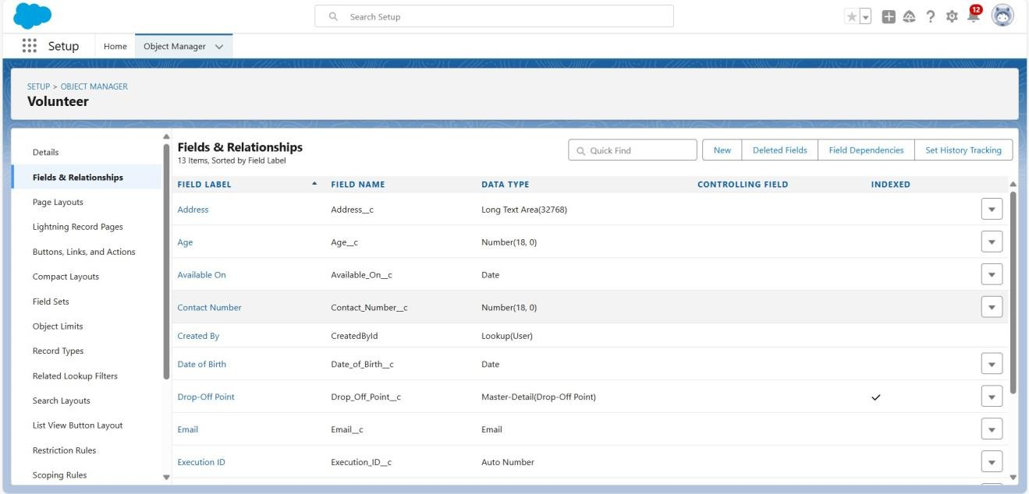

### 4.4 Creation Of Fields For Execution Details object:

1. Go to setup >> click on Object Manager >> type object name(Volunteer) in search bar >> click on the object.
2. Now click on “Fields & Relationships” >> New
3. Select Data type as a “Auto Number” and Click on Next
4. Fill the Above as following:

* Field Label : Execution ID
* Field Name : gets auto generated
* Click on required check box
* Click on Next >> Next >> Save and new.

## 33

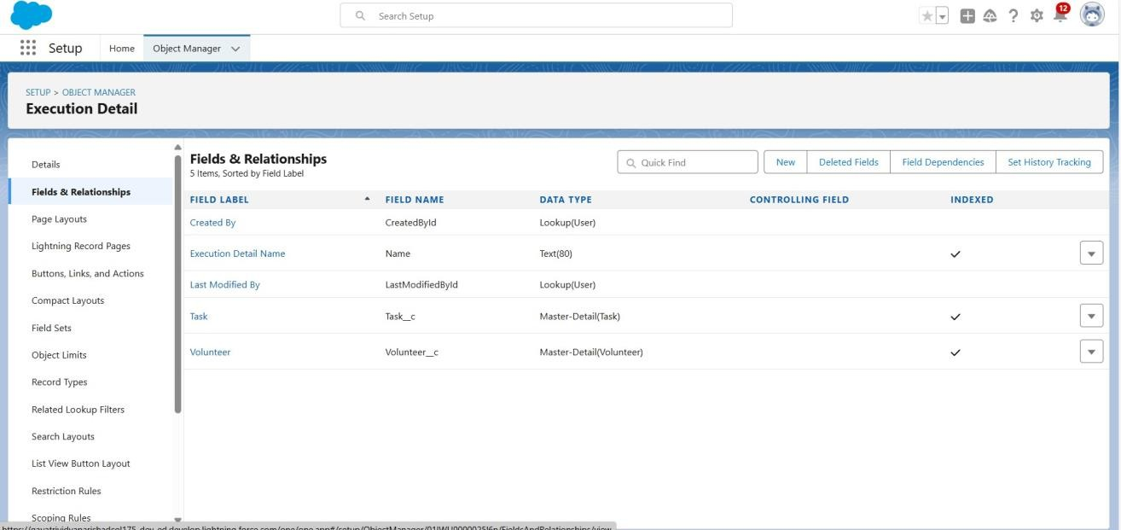

### Create Flow to create a record in Venue object

1. Go to setup >> type Flow in quick find box >> Click on the Flow and Select the New Flow.
2. Select the Screen flow. Click on create.

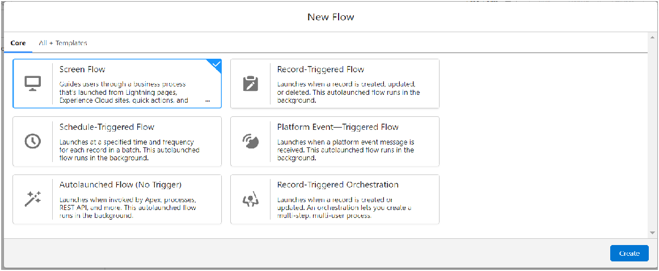

1. Click on the ‘+’ icon in between start and end, and click on screen element.
2. Under the Screen Properties: Label : Venue Details

## 34

API Name : Venue_Details

1. Now lets add components in this flow. Click on Text Component and name it as:

Label : Venue Name API Name : Venue_Name

1. Click on Email Component and name it as: Label : Email

API Name : Contact_Email

1. Click on Phone Component and name it as: Label : Phone

API Name : Contact_Phone

1. Click on Text Component and name it as: Label : Venue Location

API Name : Venue_Location

1. Click on Number Component and name it as: Label : Latitude

API Name : Latitude

1. Click on Number Component and name it as: Label : longitude

API Name : longitude

1. Next click on Done. This would like below

## 35

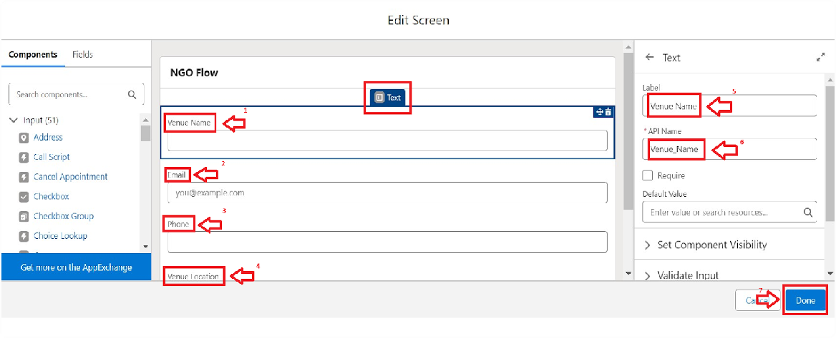

1. Click on the ‘+’ icon in between Venue details and end, and click on create record element.
2. Now label it as

Label : Create Venue Record API Name : Create_Venue_Record

How Many Records to Create : One

How to Set the Record Fields : Use separate resources, and literal values

Object : Venue

Set Field Values for the Venue : Click on ‘Add Field’ 5 times Field : Value = Contact_Email c : {!Contact_Email.value} Field : Value

= Contact_Phone c : {!Contact_Phone.value} Field : Value = Name : {!Venue_Name}

Field : Value = Venue_Location c : {!location} Field : Value = Location Latitude s : {!latitude} Field : Value = Location Longitude s : {!longitude}

1. This would look like:

## 36

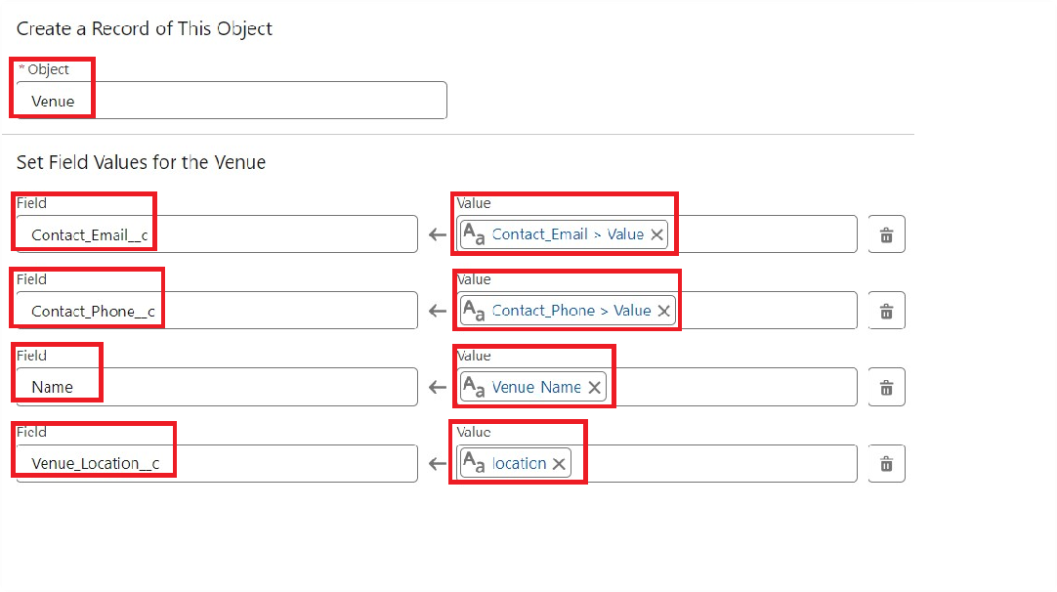

1. Click on Save as:

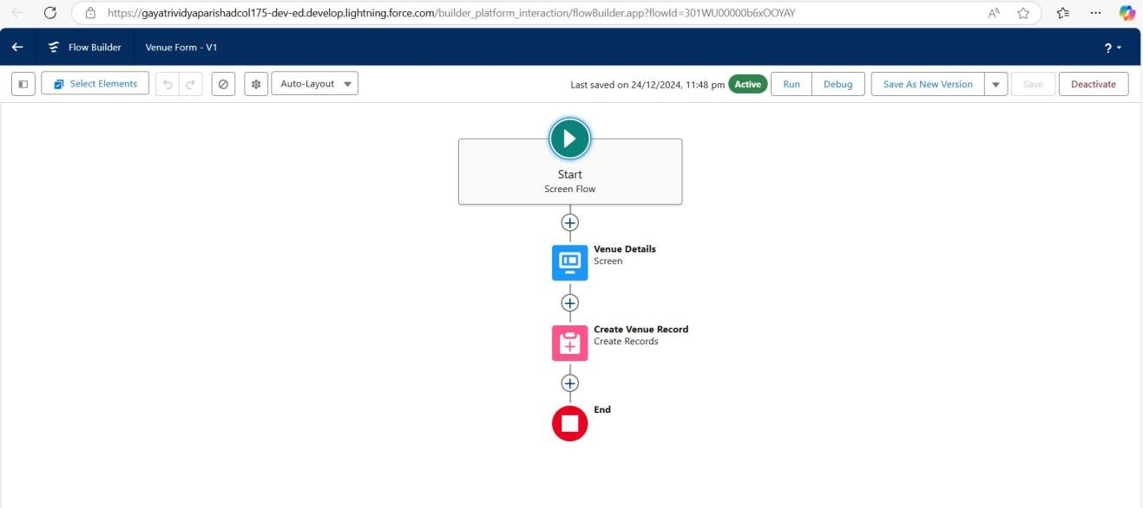Flow Label : Venue Form Flow API Name : Venue_Form

## 37

### Triggers

Triggers are pieces of Apex code that execute automatically in response to specific

events on a record.

### Create A Trigger:

* + 1. Log into the trailhead account, navigate to the gear icon in the top right corner.
    2. Click on developer console and you will be navigated to a new console window.
    3. Click on the File menu in the toolbar, and click on new >> Trigger.
    4. Enter the trigger name and the object to be triggered.

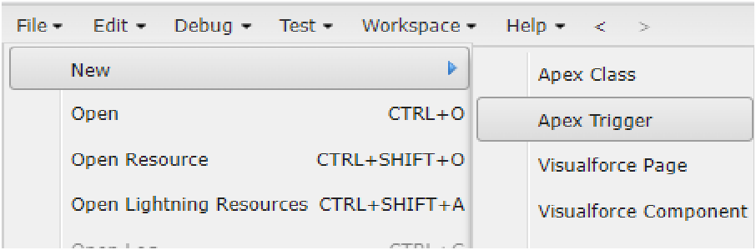

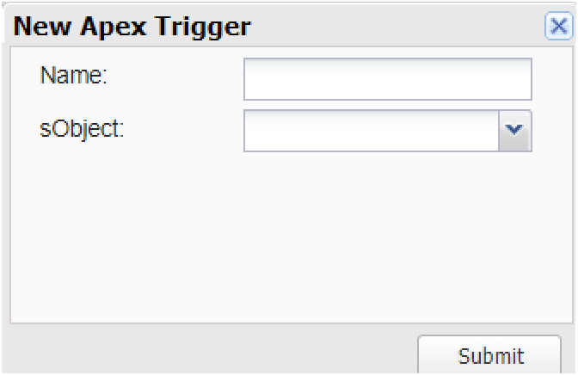

## 38

* + 1. Enter Name : DropOffTrigger sObject: Drop-Off Point
    2. Click on Submit.

### Trigger Code

trigger DropOffTrigger on Drop_Off_point c (before insert) { for(Drop_Off_point c Drop : Trigger.new){

Drop.Distance c = Drop.distance_calculation c;

}

}

### Creation Of Users

* 1. **Creation of user1:**
     1. Go to setup page >> type users in Quick Find bar >> click on users>> New user.
     2. In General Information give details as: (Note : create users as per your wish NGO’s)

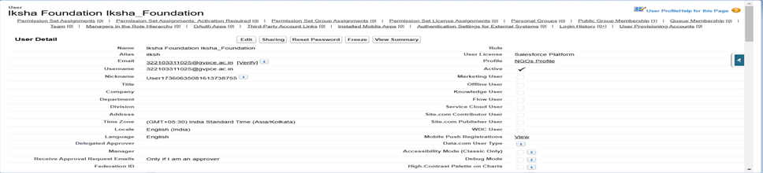

## 39

* + 1. Click on Save

### Creation of user2,user3:

* + 1. Create another Two Users by following steps in Activity - 1 with similar User License and Profile.
    2. Give Different First Name, Last Name based on Different NGO’s.

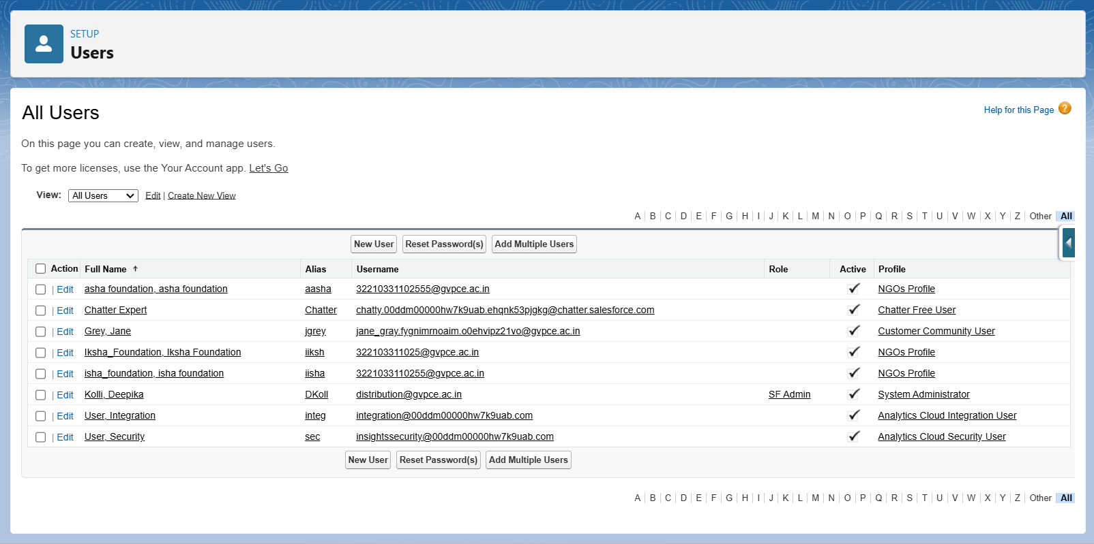

## 40

### Public groups

* 1. **Creation Of Public Group1:**
     1. Go to setup page >> type Public Groups in Quick Find bar >> click on Public Groups >> click on New.
     2. Under Group Information: Label : Satya

Group Name : Satya

Grant Access Using Hierarchies : Check

* + 1. In Search, Select Users.
    2. In Selected Members Add Nuthakki Satya Murthy and Satya Foundation Satya_Foundation

### Creation Of Public Group2,3:

* + 1. By Following Steps in Activity 1, Create other two Public Groups for other two users.

After Saving this would look like this.

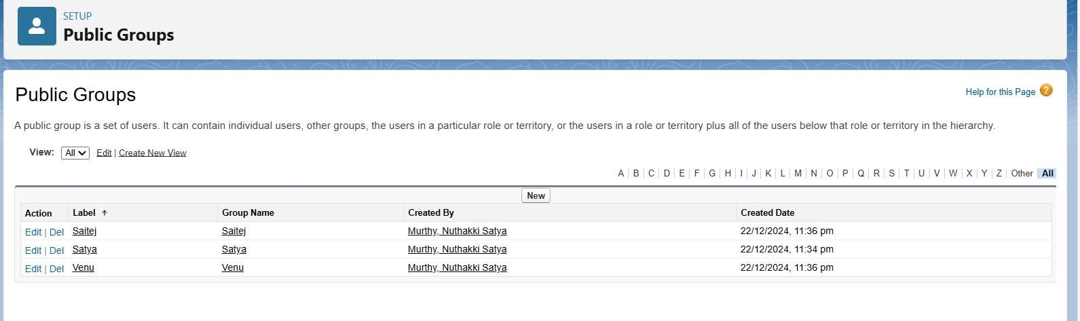

### Creation Of Report Types

1. Go to setup page >> type Report Types in Quick Find bar >> click on Report Types >> click on Continue >> Click on New Custom Report Type.
2. In Define the Custom Report Type:

## 41

Primary Object : Select Venues

Report Type Label : Venue with DropOff with Volunteer Report Type Name : Venue_with_DropOff_with_Volunteer Description : Venue with DropOff with Volunteer

Store in Category : Select Other Reports Deployment Status : Deployed

1. Click on Next
2. Near Click to relate another Object Select Drop-Off Points.
3. And also select "A" records may or may not have related "B" records.
4. Now again Near Click to relate another Object Select Volunteers.
5. Now click on Save.

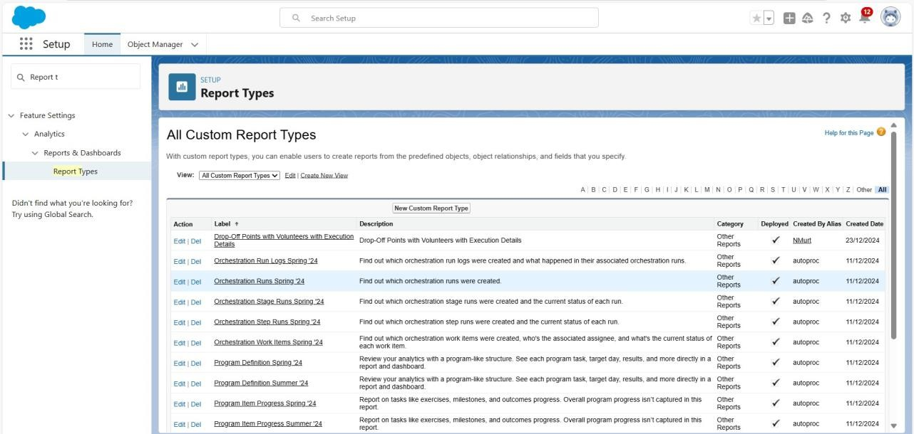

### Reports

* 1. **Creation Of Report On venue With Drop-Off Point With Volunteer:**
     1. Go to the app(FoodConnect) >> click on the reports tab
     2. Click on New Folder.

Folder Label : Custom Reports

## 42

Folder Unique Name : CustomReports

* + 1. Open Custom Reports and click on New Report
    2. Select Report Type : Venue with DropOff with Volunteer
    3. Then click on Start Report.
    4. 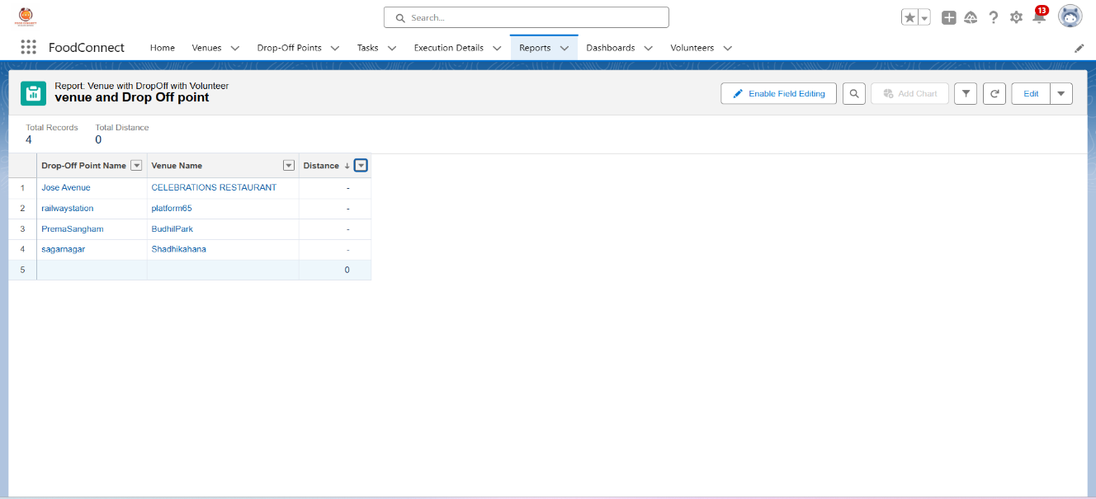In GROUP ROWS : Add Volunteer Name
    5. In Columns : Add Venue Name, Drop-Off point Name, Distance
    6. Now click on Save & Run.
    7. Give Label as :
    8. Report Name : venue and Drop Off point
    9. Report Unique Name : Auto Populated
    10. Click on Select Folder and select Custom Report, then click on Save.

### Creation Of Report On Volunteer With Execution Details And Tasks:

* + 1. Go to the app(FoodConnect) >> click on the reports tab
    2. Click on Custom Reports Folder and click on New Report
    3. Select Report Type : Volunteers with Execution Details and Tasks.
    4. Then click on Start Report.

## 43

* + 1. In GROUP ROWS : Volunteer ID
    2. In Columns : Add Volunteer : Volunteer Name, Task : Task Name, Execution Detail : Execution Detail Name, Volunteer: Owner Name, Task: Date, Task : Rating.

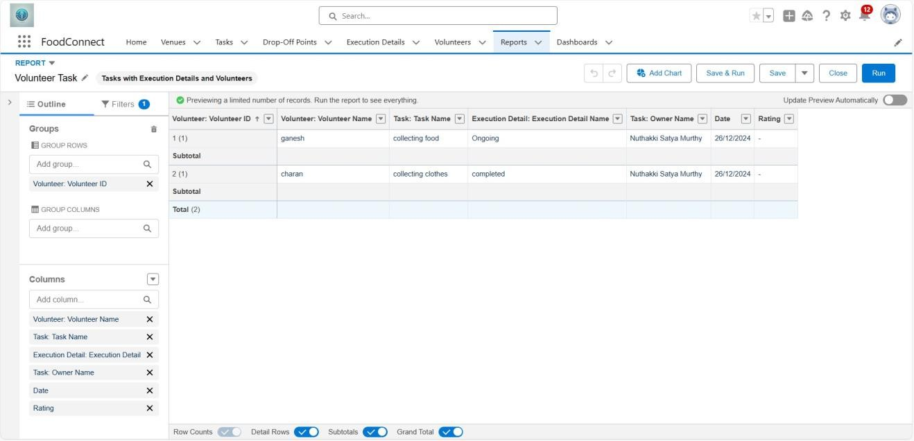

* + 1. Now click on Save & Run.
    2. Give Label as :

Report Name : Volunteer Task

Report Unique Name : Auto Populated

* + 1. Click on Select Folder and select Custom Report, then click on Save.

### Dash Boards

* 1. **Adding Venue And Drop-Off Point To Report The Dashboard:**
     1. Go to the app(FoodConnect) >> click on the Dashboards tab.
     2. Click on New Folder.

Folder Label : Custom Dashboards Folder Unique Name : Auto Populated

## 44

* + 1. Open Custom Dashboards and click on New Dashboards
    2. Name : Organization Details
    3. Click on Widget and select Chart or Table
    4. In Select Report : Select venue and Drop Off point Report.
    5. Then click on select
    6. In Add Component:

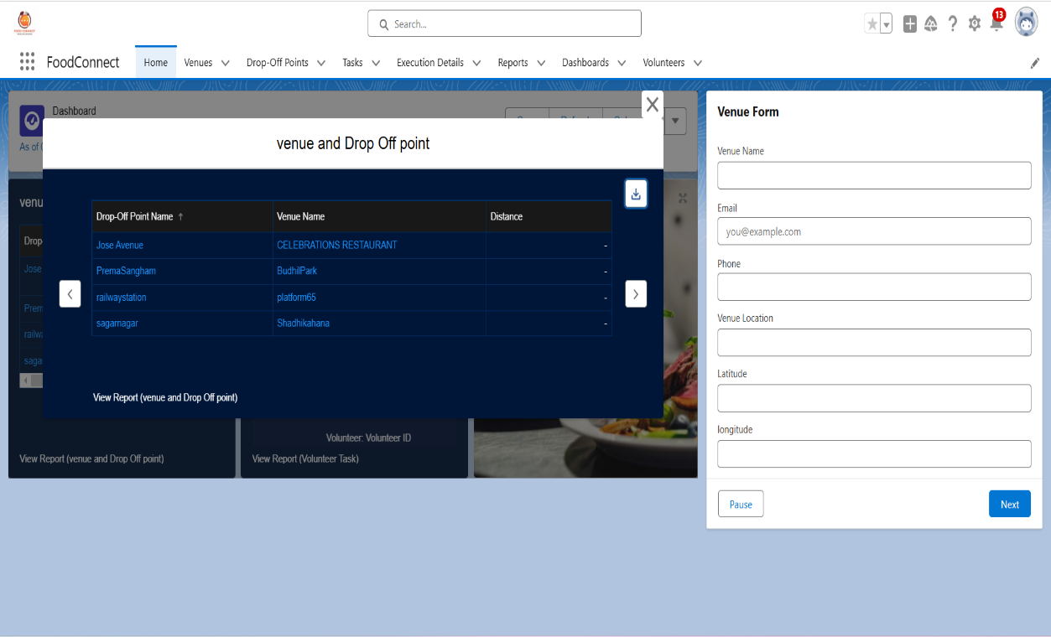Display As : Select Lightning Table Component Theme : Select Dark (Optional)

* + 1. Now click on save.

## 45

### Adding Volunteer Task Report To The Dashboard:

* + 1. Click on Widget and select Chart or Table
    2. In Select Report : Select Volunteer Task Report.
    3. Then click on select
    4. In Add Component:

Display As : Select Line Chart

Component Theme : Select Dark (Optional)

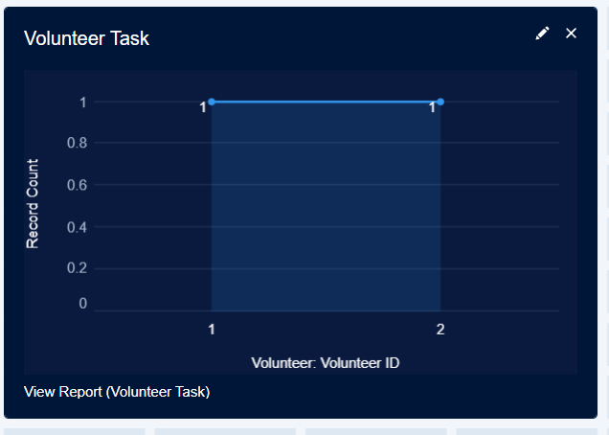

* + 1. Now click on save.

### Adding A Picture To The DashBoard:

* + 1. Click on Widget and select Image. Then click on Browse Files.
    2. Then Select the Picture you want to upload in this Dashboard.
    3. Then click on Save As :

Name : Task Execution Details

Click on Select Folder and select Custom Dashboards

* + 1. Click on Select Folder and then Save.

## 46

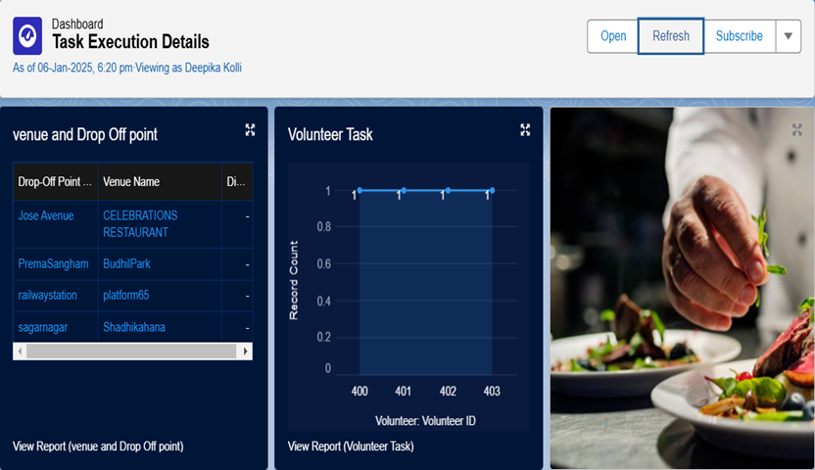

### Creation Of Sharing Rules

1. Go to setup >> type Sharing Settings in quick find box >> Click on the Sharing Settings.
2. Scroll down and find Drop-Off point Sharing Rules.
3. Click on new near Drop-Off point Sharing Rules and Name it as: Label : Rule 1

Rule Name : Rule_1

1. Select your rule type : Select Based on criteria.
2. Select which records to be shared:

Field : Operator : Value = Distance : less than : 15

1. Select the users to share with : Near Share With Public Groups : Iksha
2. Click on Save.
3. Click on new near Drop-Off point Sharing Rules and Name it as: Label : Rule 2

Rule Name : Rule_2

## 47

1. Select your rule type : Select Based on criteria.
2. Select which records to be shared:

Field : Operator : Value = Distance : greater than : 15 Field : Operator : Value = Distance : less or equal : 30

1. Select the users to share with : Near Share With Public Groups : NSS
2. Click on Save.
3. Click on new near Drop-Off point Sharing Rules and Name it as: Label : Rule 3

Rule Name : Rule_3

1. Select your rule type : Select Based on criteria.
2. Select which records to be shared:

Field : Operator : Value = Distance : greater than : 30 Field : Operator : Value = Distance : less or equal : 50

1. Select the users to share with : Near Share With Public Groups : Street Cause
2. Click on Save.

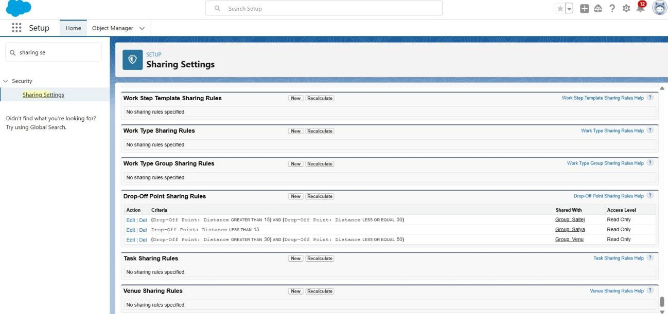

## 48

### Creation Of Home Page

1. Go to setup >> type Lightning App Builder in quick find box >> Click on the Lightning App Builder and Select the New.
2. Select Home Page and give Label as HOME Page.
3. Select Standard Home Page.
4. Near Components search for Flow and Drag and Drop in Right Side Section..
5. On the right hand side:

Flow : Venue Flow

1. Near Components search for Dashboard, then Drag and Drop it in first Section.
2. Click on Save and Activation, then click on App Default, then Add Assignments.
3. Add FoodConnect App and then Save.
4. FoodConnect Home Page would Look Like this.

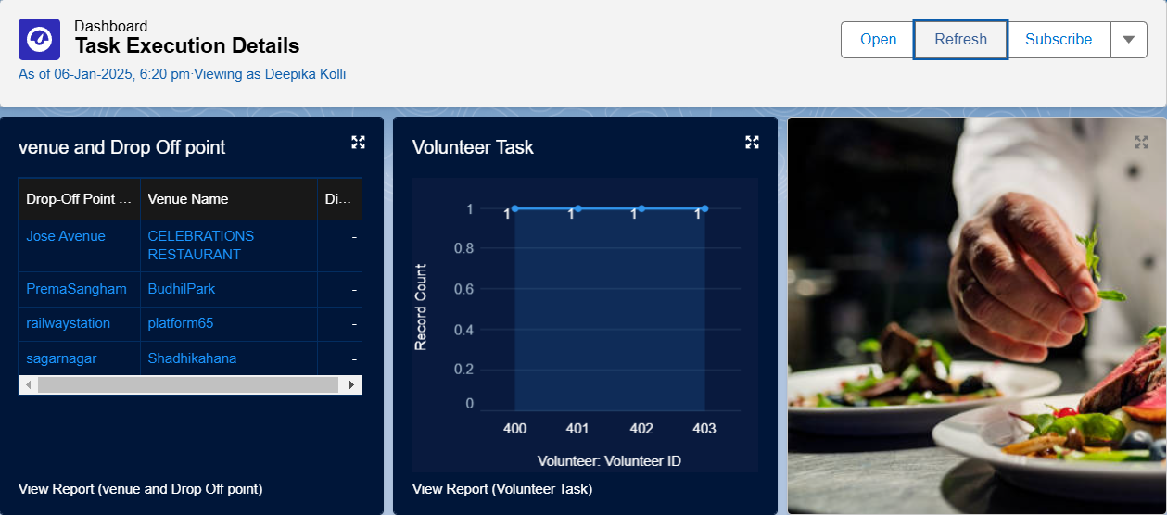

**49**

# Testing and Validation

### Unit Testing:

Testing the Drop-Off Trigger

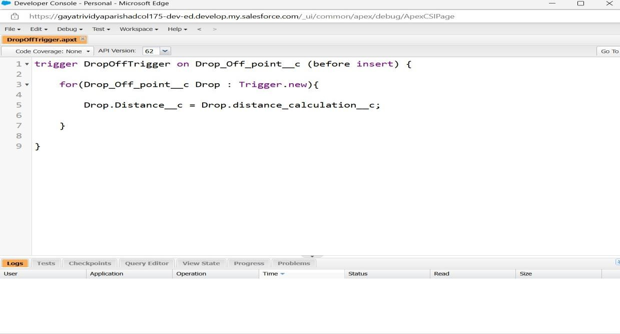

## 50

### User Interface Testing:

Here we can see the Dashboard with Venue And Drop Point is tested and Volunteer task Dashboard where we can observe a graph plotted between Record Count and Volunteer:Volunteer ID, Which shows That UI is perfectly developed.

### Validation:

We can Observe That cant Create Duplicate Fields,Objects and Every User,Public Groups details are Valid.

* + - **Venue Form**: Ensures all mandatory fields (Venue Name, Email, Phone, Venue Location) are filled, with real-time error messages for missing or incorrect inputs. Email and numeric fields are validated for proper formats.
    - **Venue and Drop-Off Point Table**: Data is dynamically fetched and validated to ensure accuracy, with functional sorting and scrolling for large datasets.
    - **Volunteer Task Section**: Graph data is validated to accurately reflect

real-time information, and links are tested for correct redirection



## 

## 51

* + - **Dashboard Controls**: Buttons like "Open," "Refresh," and "Subscribe" are tested to confirm proper functionality and data updates.

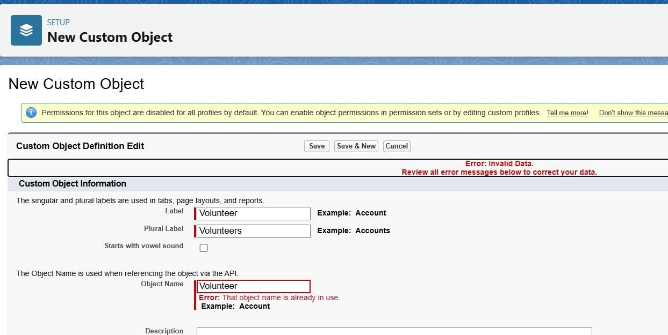

## 5

1. **Key Scenarios Addressed by Salesforce in Implementation Of The Project**

* **Customer Relationship Management (CRM):** Salesforce handles managing and analyzing customer interactions and data, improving customer service and engagement.
* **Sales Process Automation:** It automates various sales processes, like tracking leads, opportunities, and performance, helping sales teams close deals faster.
* **Marketing Campaigns and Engagement:** Salesforce enables personalized marketing campaigns and provides tools for tracking and analyzing their effectiveness.
* **Analytics and Reporting:** Salesforce helps generate real-time reports and dashboards, providing insights into business operations and customer behavior.
* **Collaboration and Integration:** The platform integrates with other

## 52

systems and fosters team collaboration, ensuring streamlined workflows and improved productivity.

# Conclusion

The **Food Connect** app has successfully created a digital platform to bridge the gap between surplus food and those in need. By implementing real-time tracking, efficient coordination of volunteers, and a user-friendly interface, the app has streamlined the process of food donation and distribution. Key milestones include integrating donation requests, volunteer management features, and creating impact reporting tools. With this project, we have taken a step toward reducing food waste and addressing hunger in underserved communities, while fostering a sense of community responsibility and involvement.

**53**